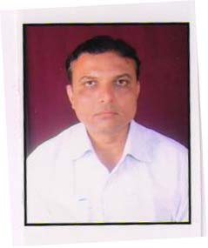

Pt. Harishankar Shukla Memorial College is doing a marvelous task of spreading the holy concept of education in this new state of Chhattisgarh. Being a tribal dominant state and with an affordable fee structure ,this college nurtures and plays a major role not only in the field of education but also in making a viable professional and human being. I being associated with this college for more then 17 years feel proud that the vision and mission of the management people especially the chairman and the principal plays a pivotal role in the development of academic, cultural and 360 degree activities.

Dr.Sanjay Awasthi
Head(Department of Management)
Pt.Harishankar Shukla Memorial College

